Name: Ellyssa Mae G. Mangco

Year & Section: 3/BSCS/A

* What are the types of databases?
* Databases are a necessary element of everyday life in the modern world. Most computer functions would be rendered obsolete if they were not present. If you rely on a computer to store information, whether for personal or professional reasons, you should be aware of the various types of databases available and how to use them. We'll go over what databases are and how to use them, as well as the most frequent sorts of databases you'll encounter.

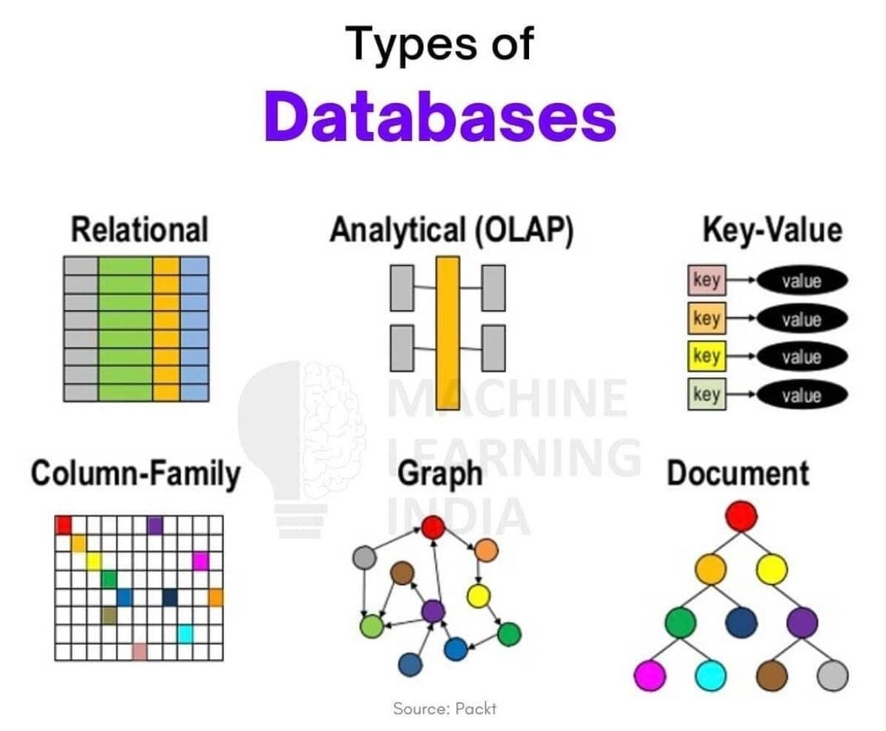

* Relational Databases
* A relational database is a collection of data elements that have pre-defined relationships. These objects are laid down in a tabular format, with columns and rows. ... A primary key is a unique identifier that can be assigned to each row in a table, and foreign keys can be used to link rows from other tables together.

Ex. Users can manage preset data relationships across various databases using traditional relational databases. Microsoft SQL Server, Oracle Database, MySQL, and IBM DB2 are just a few examples of popular relational databases.

* Analytical (OLAP) Databases
* An analytical database, often known as a business database, is a read-only system that keeps historical data on business variables like sales performance and inventory levels. ... The data is updated on a regular basis to reflect the most recent transaction data from the organization's operational systems.

Ex. HP Vertica, Pivotal Greenplum,Teradata, Paraccel / Actian, Netezza, SAP IQ.

* Key-Value Databases
* A key-value database is a non-relational database that stores data using a straightforward key-value mechanism. A key-value database is a collection of key-value pairs that serves as a unique identifier for the data. Both keys and values might be simple or complicated compound items.

Ex. A key-value store or key-value database's core data format is a key-value pair, however key-value pairs have been around for much longer than software. The key is the person's or company's name, and the value is the phone number, like in a telephone directory.

* Column-Family Databases
* A column family is a database entity that has linked data columns in its columns. It's a tuple (pair) made up of a key–value pair with the key mapped to the value...

Ex. Column families are collections of data that are frequently accessed together. We would frequently access a Customer's Profile information at the same time, but not their Orders. Others include HBase, Hypertable, and Amazon DynamoDB [Amazon DynamoDB]. Cassandra is one of the most popular column-family databases.

* Graph Database
* a **graph** database is a database designed to treat the relationships between data as equally important to the data itself.

Ex. Graph Databases are already being used by Instagram, Twitter, Facebook, Amazon, and virtually all other applications that need to quickly query data distributed across an endlessly growing and highly dynamic network of data.

* Document Database
* A **document database** is a type of non-relational database that is designed to store and query data as JSON-like documents.

Ex.  document DBMS include **JSON, XML docs, Catalogs**, serialized PDFs and Excel docs, Profile data, and serialized objects.